Assignment 2

Author：Yadong Mao

**Task 1**

Command: python ./task1.py ./2csn.pdb

Distance threshold: 10

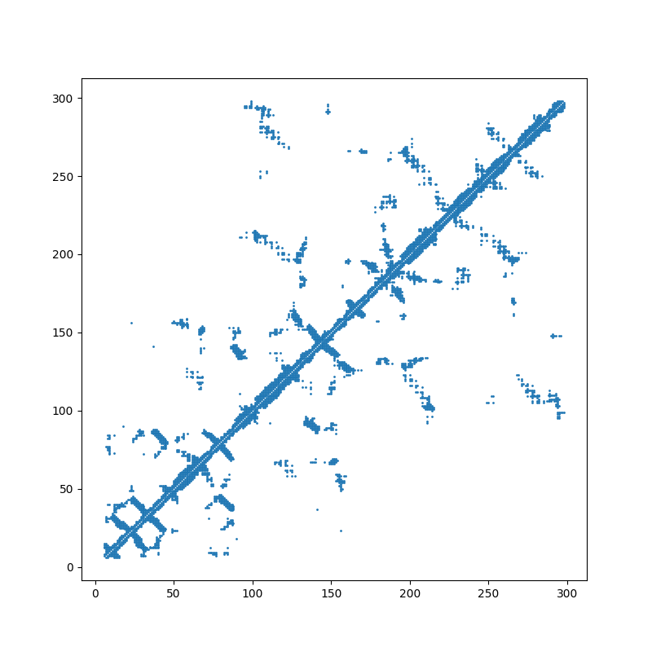

**Task 2**

Command: python ./task2.py ./2csn.pdb

Distance threshold: 10

文本

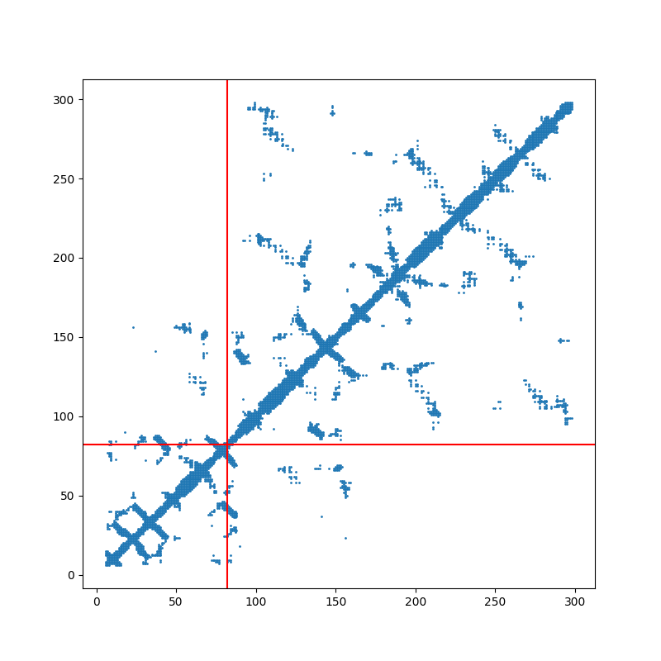

**Task 3**

Command: python ./task3.py ./2csn.pdb

Distance threshold: 10

Similarities and differences :

The split point obtained for task two and task three is around 85-105.

The split point obtained in task two is s-iCode equal to 88.

The split point obtained in task three is approximately where s-iCode is equal to 100.

The clear split point can be obtained by the DOMAK method.

The fuzzy split points can be obtained by the Kernighan-Lin method.

The two sets obtained by the Kernighan-Lin method will cross each other at the split point.

**Task 4.1（1HZH_H.pdb）**

Command: python ./task4.py ./1HZH_H.pdb

Distance threshold: 10

Find all domains by setting min residue and min split score.

The program can find 4 domains on the 1HZH_H.pdb file, as shown on the diagonal line in the figure.

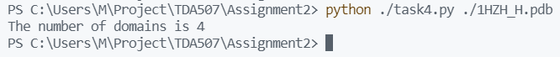

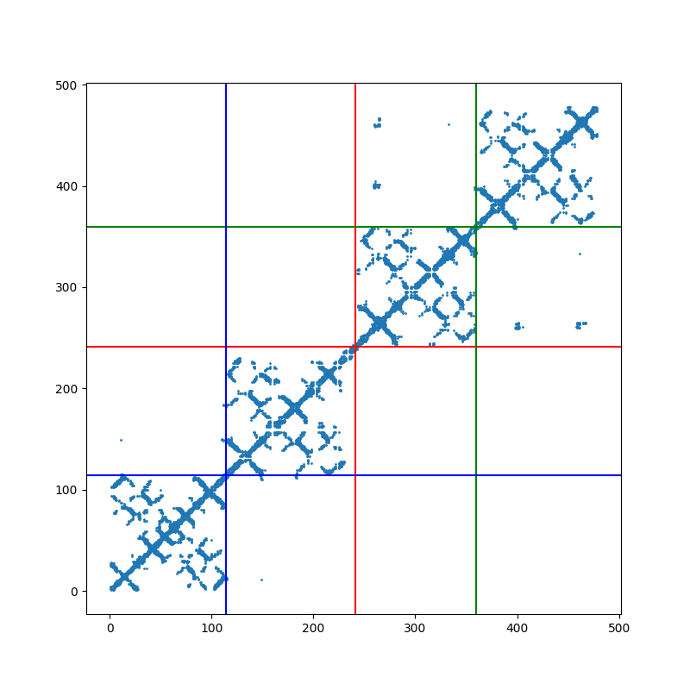

**Task 4.2（4GAF_B.pdb）**

Command: python ./task4.py ./4GAF_B.pdb

Distance threshold: 10

The program can find 3 domains on the 4GAF_B.pdb file, as shown on the diagonal line in the figure.

